How to configure a PO Line Cancellation Reason and report on it in Alma Analytics | 

Yoel Kortick
Senior Librarian

Question
How can we get statistics according to how many POLs were cancelled and why they were cancelled?

Answer

ONE
First define POL Cancellation reasons.
This is done at Configuration Menu > Acquisitions > Purchase Orders

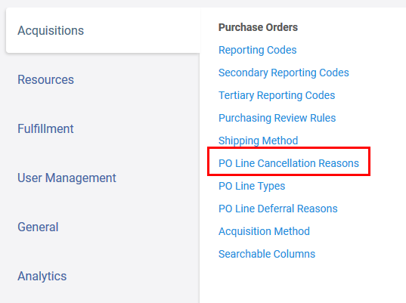

TWO
Add a code and name of the cancellation reasons which you will want to use.
Here we have defined
- ENTRY-ERROR
- ORDER_CLOSED
- LIBRARY_CANCELLED
- VENDOR_CANCELLED

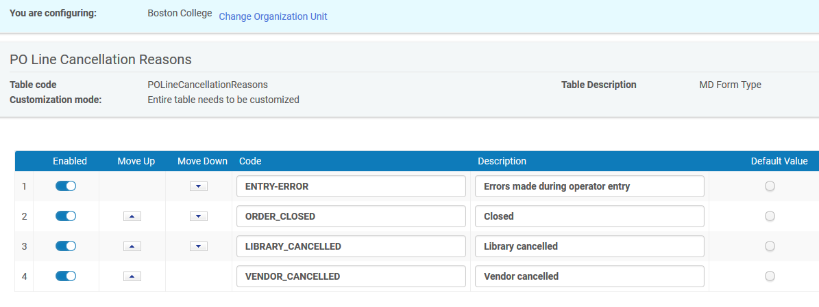

THREE
Now see these options when you cancel an order

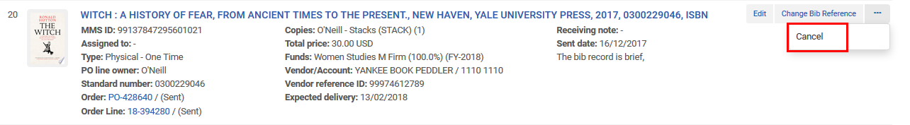

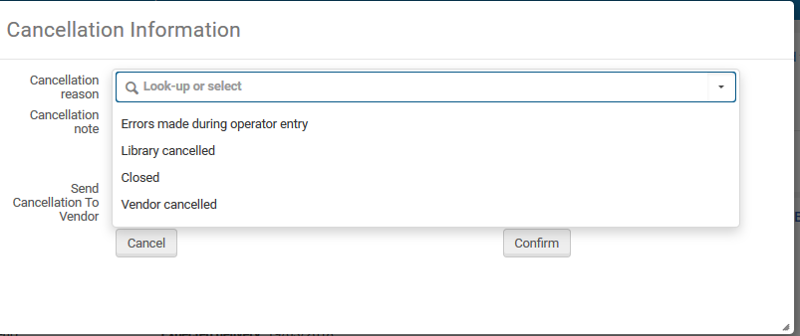
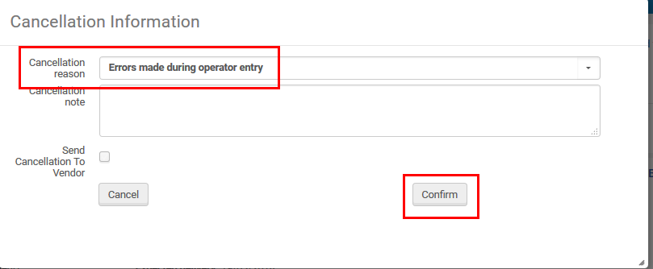

FOUR
Now in Analytics in the Funds Expenditure subject area we can display and filter by these reasons:

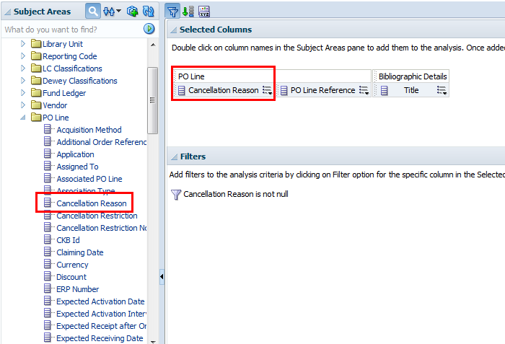

FIVE

See results:

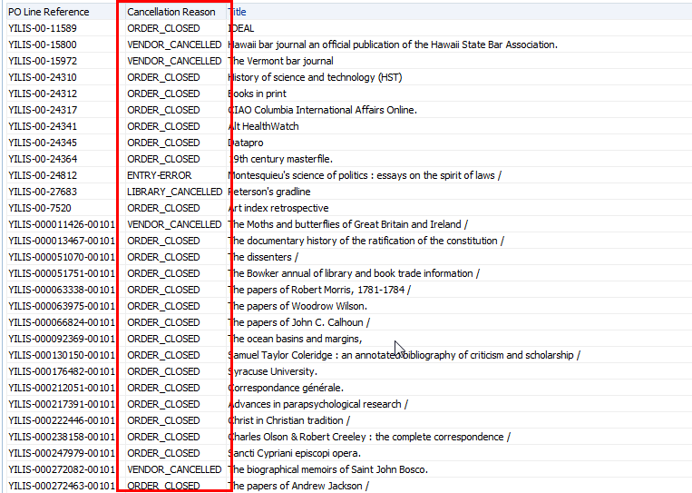

SIX
You can also get the number of POLs per cancellation reason
Do ‘edit formula’ on the ‘PO Line Reference’ and instead of this
"PO Line"."PO Line Reference"
Put this
COUNT("PO Line"."PO Line Reference")

Change the column heading from
PO Line Reference
To
PO Line Reference Amount

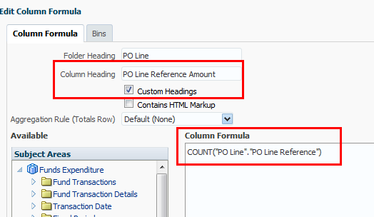

Display the reason and the PO Line Reference Amount

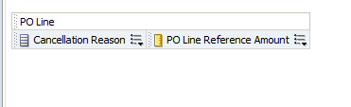

SEVEN

See results

